Email Depot Project Plan

Jovan, Ethan, & Melissa

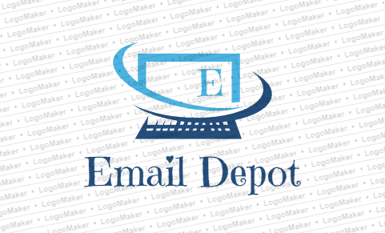

1. **Introduction**

a. **Scope and purpose of document (Melissa)** – In one paragraph, describe what is contained in this document and the general purpose of a Project Plan. In a separate paragraph, provide an overview of your application.

The general purpose of the Project Plan for Email Depot is an app, which will allow the user an easy way to view all their emails from one source. The inbox will be easily viewable. Features of the Email Depot will include scheduling, blocking, organizing, selecting favorites, as well as, reminders. This document contains the System Scope, which includes Problem/Opportunity Description, Anticipated Business/Personal Benefits, System Capabilities and System Context. The document also contains, the Schedule which creates a Work Breakdown Structure Chart in Microsoft Project, Staff Organization which contains a Team Structure, and Tracking and Control mechanisms to track changes to the document.

An overview of the Email Depot is an app which simplifies the way the user will receive and send emails. Emails are collected from different email services and are stored in one inbox, which is viewed easily. The user will have the opportunity to block emails, as well as organizing the emails they want. The app will also allow the user to schedule when they want their emails to be sent out.

b. **System Scope**

i. **Problem/Opportunity Description(Ethan)** – in 1-2 paragraphs, describe what the goal is of your project. What problem are you trying to solve or what opportunity are you trying to take advantage of.

With the creation of Email Depot we are looking to make checking multiple email accounts easier and more efficient by consolidating them all in one inbox. Most people have more than one email account on more than one platform so this app is crucial for time saving.

ii. **Anticipated Business/Personal Benefits(Jovan)** – In one paragraph, describe what your company will hope to achieve by creating this application. In another paragraph, describe the benefits to the users.

The goal our company hopes to achieve by creating this application is to offer people an easier way to receive and send emails as well as schedule them. We are hoping to save our current users considerable time and build trust, which would allow us to attract new users and eventually become the number one email application.

Email Depot will be free for everyone around the world. With a single login, users will be able to receive and send emails on every email platform that’s added on our application. Another valuable feature is Blocking, which allows users to block certain sources, by simply clicking on the “Block” button. The users will also have the option to place a source in “Favorites”, so instead of scrolling down and looking for a specific email, their favorite source will always appear at the top. All things considered, our company believes that users will have a safe and easy way of communicating, while saving considerable time.

iii. **System Capabilities (Melissa)** – list of major functions of the system. These are taken from the Project Proposal and expanded upon.

The major functions of the Email Depot are as follows: Collection of Emails, Scheduling, Blocking, Organizing, Favorites, and Reminders.

The Collection of Emails: Separate email services such as Gmail, Hotmail, Yahoo, and AOL, will be displayed in one inbox for easy viewing. The user will not have to log into different email accounts to view their individual emails.

Scheduling: If the user wishes, emails can be sent out at a specific times, allowing emails to arrive at a time that may not be convenient for them to send out.

Blocking: Users will have the ability to block unwanted emails from certain sources. This will diminish the amount of unwanted emails.

Organizing: Users will have the ability to organize emails by storing them into certain categories, such as, personal, business, school, etc,. This will allow for easy access to emails based on how the user organized the setup.

Favorites: The favorites ability will allow the user to select which emails are displayed first. This is a benefit because the user will be able to see what is important first and not have to search through emails.

Reminders: The user will be able to set up reminders to reply to emails, and also remind users that they have unopened emails. This way emails will not go unread.

iv. **System Context (Melissa)** – Using Visio or a similar drawing tool, create a System Context Diagram which depicts the primary uses of the system and the information that is exchanged between them and the system

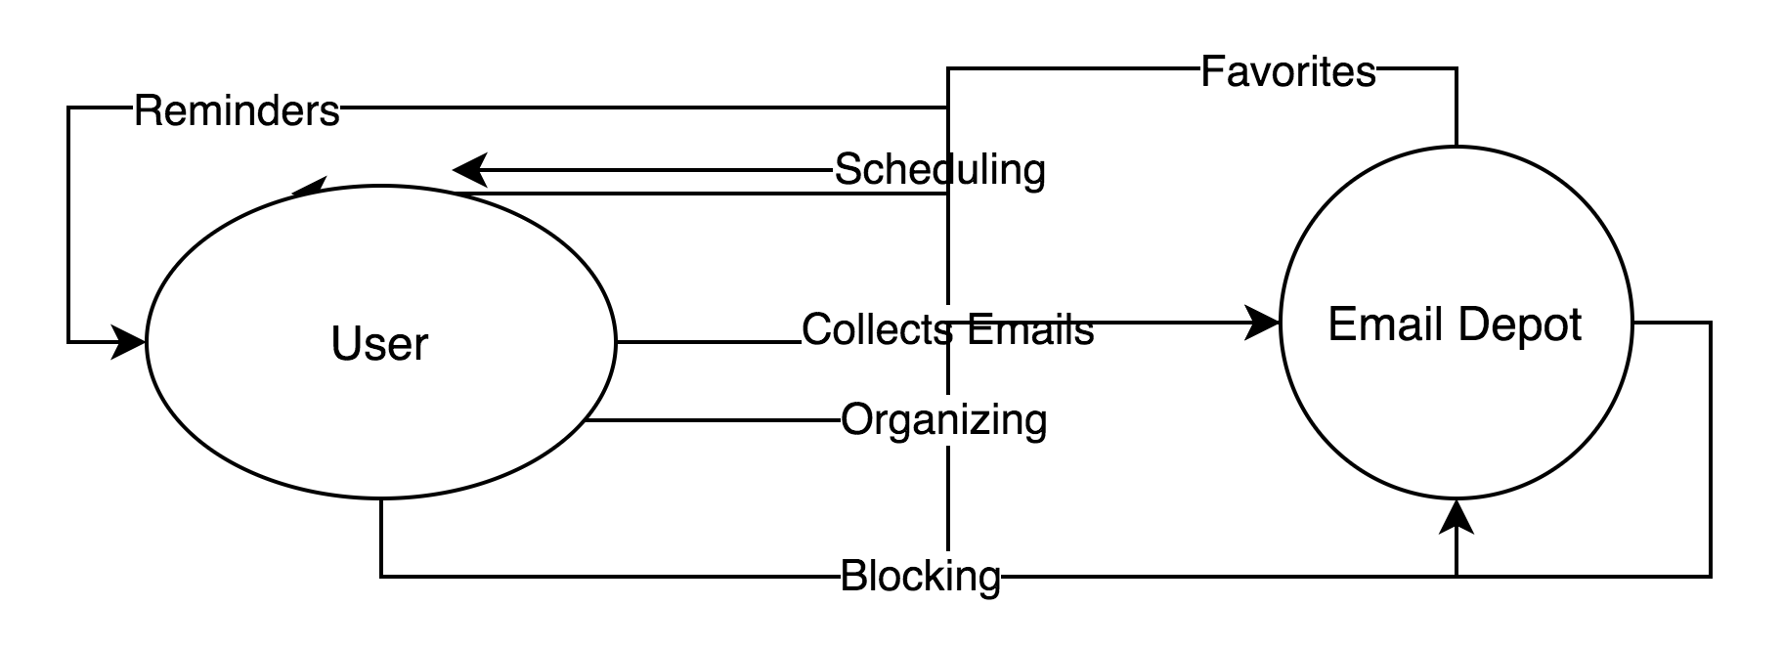

2. **Schedule(Ethan)** –Uploaded onto Github.

3. **Staff Organization(Ethan)**

a. **Team Structure** – how is your team organized; who is the team leader and how are you organized?

Team Leader-Ethan-Class Diagram and Description,State Chart Diagrams,First cut domain sequence diagrams

Jovan-Use case diagrams and scenarios,System design document introduction,First cut domain sequence diagrams

Melissa-System Sequence Charts,Class Diagrams,First cut domain sequence diagrams

4. **Tracking and control mechanisms** – Describe how you plan to track changes to this document (especially those items in Section 2) and techniques that you will use to monitor the progress of the various tasks. For example, do you have regular meetings, how do you use groupware to keep the documents in-synch and current, etc.

Our team has an agile meeting at least once a week. These meetings are critical for the development of our application since we discuss updates on our project, our plan tasks, share project information etc. All members of the team have different tasks to complete. We use a project management tool called Trello where we keep track of the various tasks.